LAB TASK - 1
- Write a program to print the binary representation of a number using loops.
Example: Input = 5, Output = 101.

CODE:

#include <stdio.h>
int main() {
int n, bin[32], i = 0;
printf("Enter the input:");
scanf("%d", &n);

while (n > 0) {
bin[i] = n % 2;
n = n / 2;
i++;
}
printf("Output: ");
for (i = i - 1; i >= 0; i--)
printf("%d", bin[i]);

return 0;
}

OUTPUT:

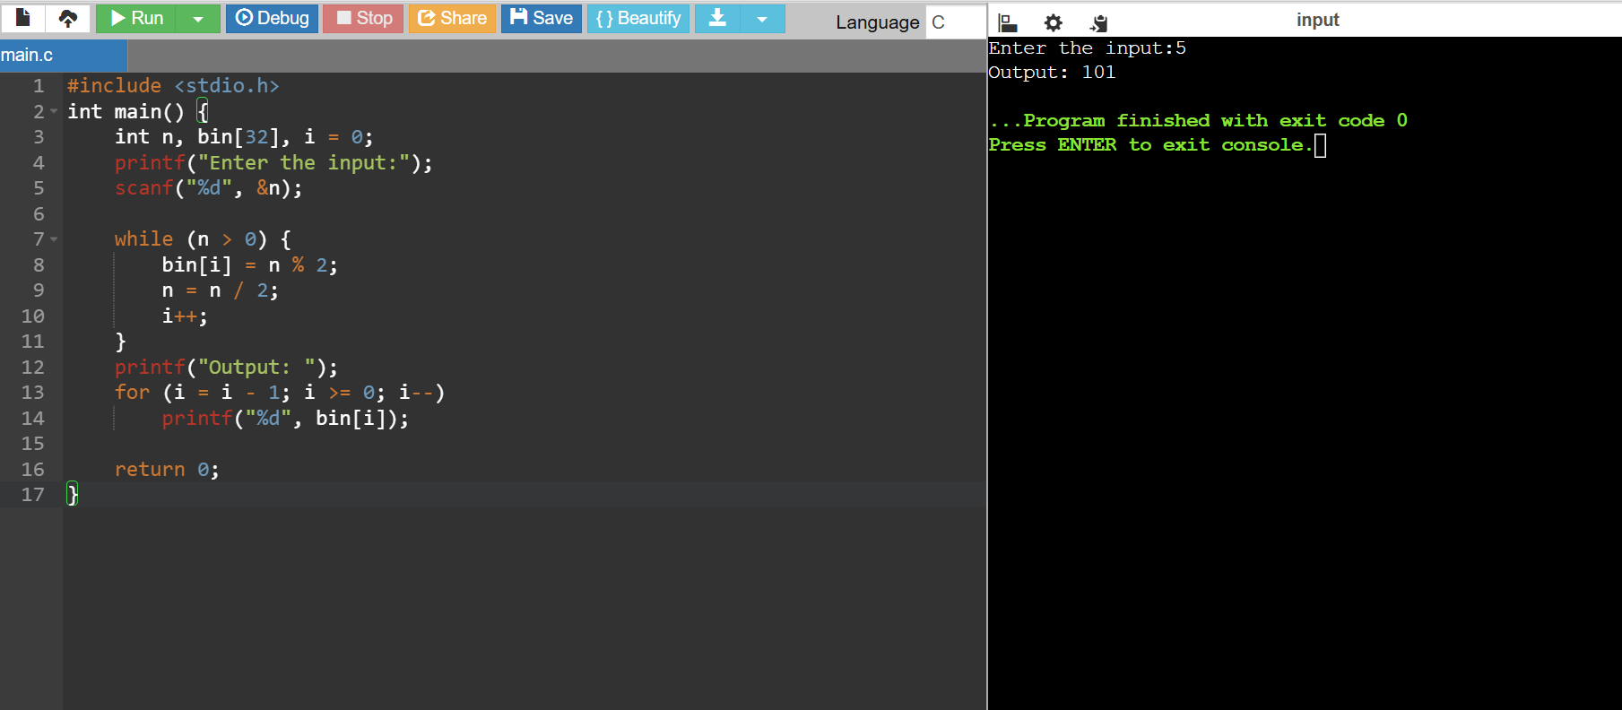

- Write a program to count the number of vowels and consonants in a string using pointers.

CODE:

#include <stdio.h>
int main() {
char str[100];
char *p;
int v = 0, c = 0;
printf("Enter a String: ");
scanf("%s", str);
p = str;

while (*p != '\0') {
if (*p=='a'||*p=='e'||*p=='i'||*p=='o'||*p=='u'||
*p=='A'||*p=='E'||*p=='I'||*p=='O'||*p=='U')
v++;
else
c++;
p++;
}

printf("Vowels = %d\nConsonants = %d", v, c);
return 0;
}

OUTPUT:
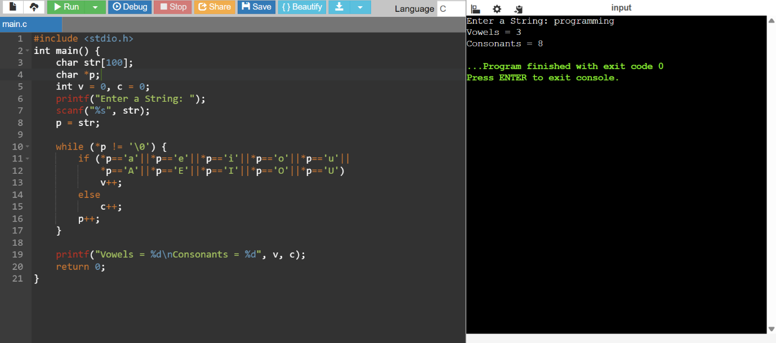

- Write separate functions for addition, subtraction, multiplication, and division. Call these functions from a menu-driven program.

CODE:

#include <stdio.h>

int add(int a, int b) { return a + b; }
int sub(int a, int b) { return a - b; }
int mul(int a, int b) { return a * b; }
float div(int a, int b) { return (float)a / b; }

int main() {
int a, b, ch;
printf("Enter two numbers: ");
scanf("%d %d", &a, &b);

printf("\nMenu:\n");
printf("1. Addition\n");
printf("2. Subtraction\n");
printf("3. Multiplication\n");
printf("4. Division\n");
printf("Enter your choice: ");
scanf("%d", &ch);

switch (ch) {
case 1:
printf("Result = %d", add(a, b));
break;
case 2:
printf("Result = %d", sub(a, b));
break;
case 3:
printf("Result = %d", mul(a, b));
break;
case 4:
if (b != 0)
printf("Result = %.2f", div(a, b));
else
printf("Error: Division by zero");
break;
default:
printf("Invalid choice");
}

return 0;
}

OUTPUT:

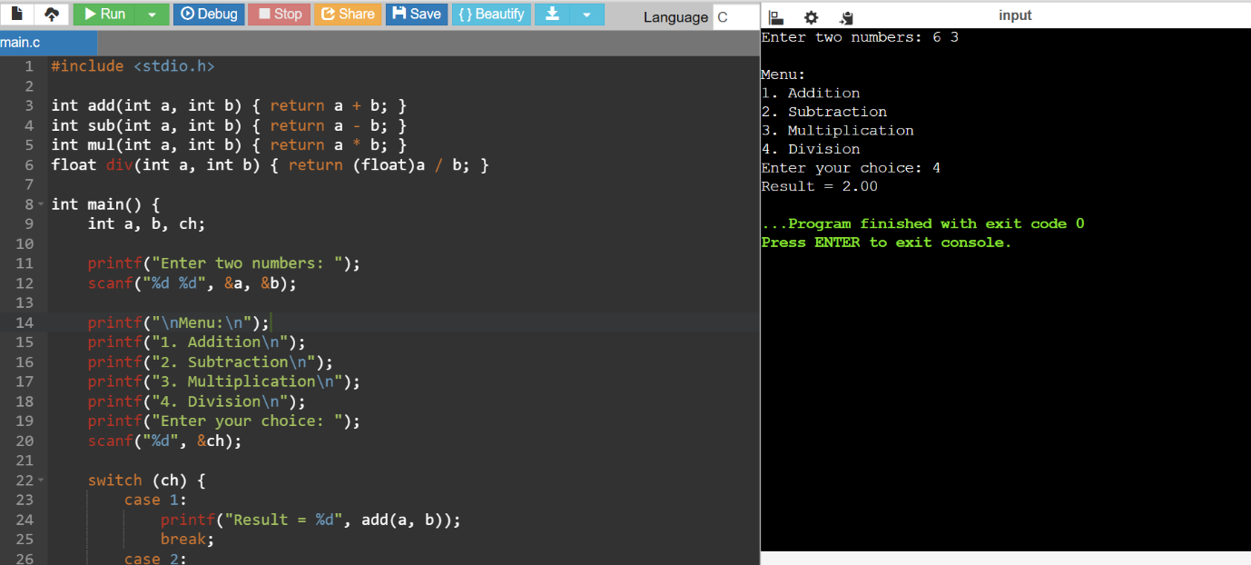

- Write a program to print a diamond-shaped pattern using loops.

CODE:

#include <stdio.h>

int main() {
int n, i, j, s;
printf("Enter the value of n:");
scanf("%d", &n);

for (i = 1; i <= n; i++) {
for (s = i; s < n; s++)
printf(" ");
for (j = 1; j <= 2*i-1; j++)
printf("*");
printf("\n");
}

for (i = n-1; i >= 1; i--) {
for (s = n; s > i; s--)
printf(" ");
for (j = 1; j <= 2*i-1; j++)
printf("*");
printf("\n");
}
return 0;
}

OUTPUT:

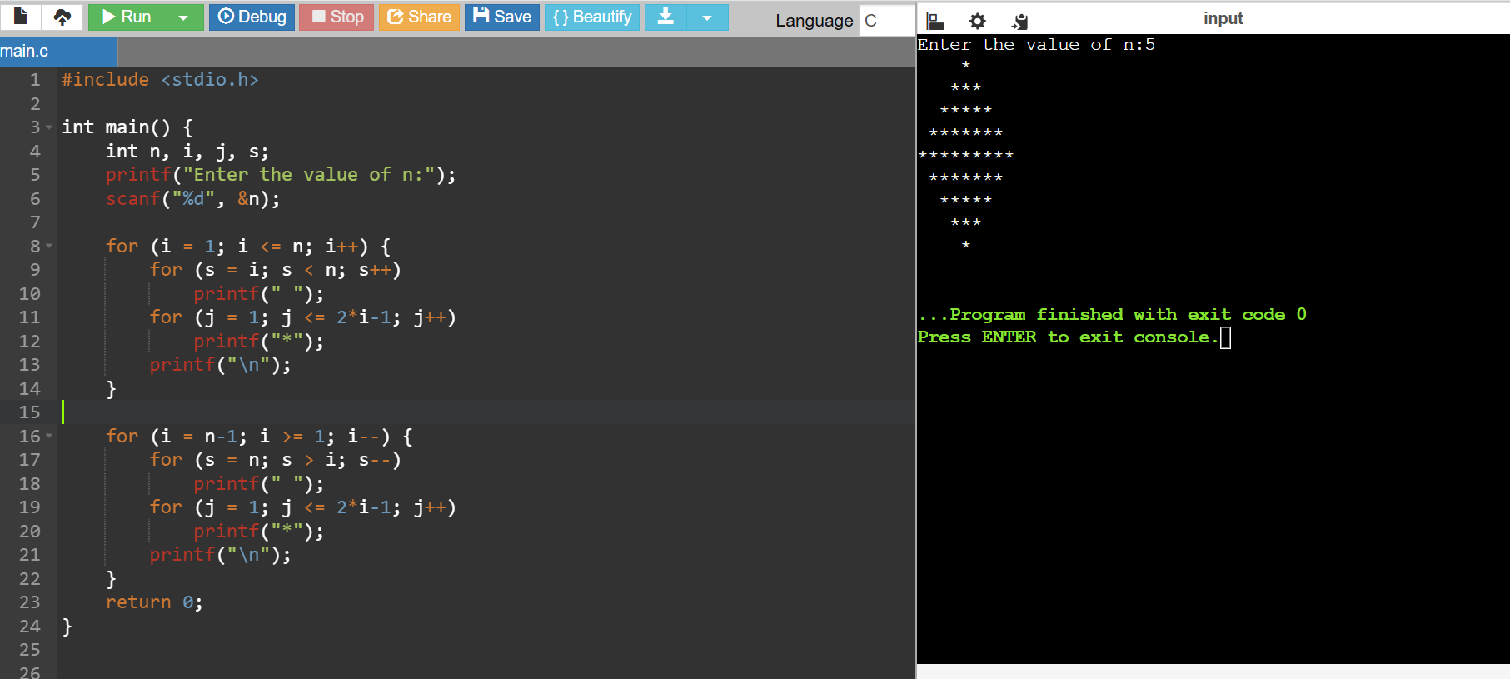

- Write a program to find the length of a given string using pointers.

CODE:

#include <stdio.h>

int main() {
char str[100];
char *p;
int len = 0;
printf("Enter the String:");
scanf("%s", str);
p = str;

while (*p != '\0') {
len++;
p++;
}

printf("%d", len);
return 0;
}

OUTPUT:

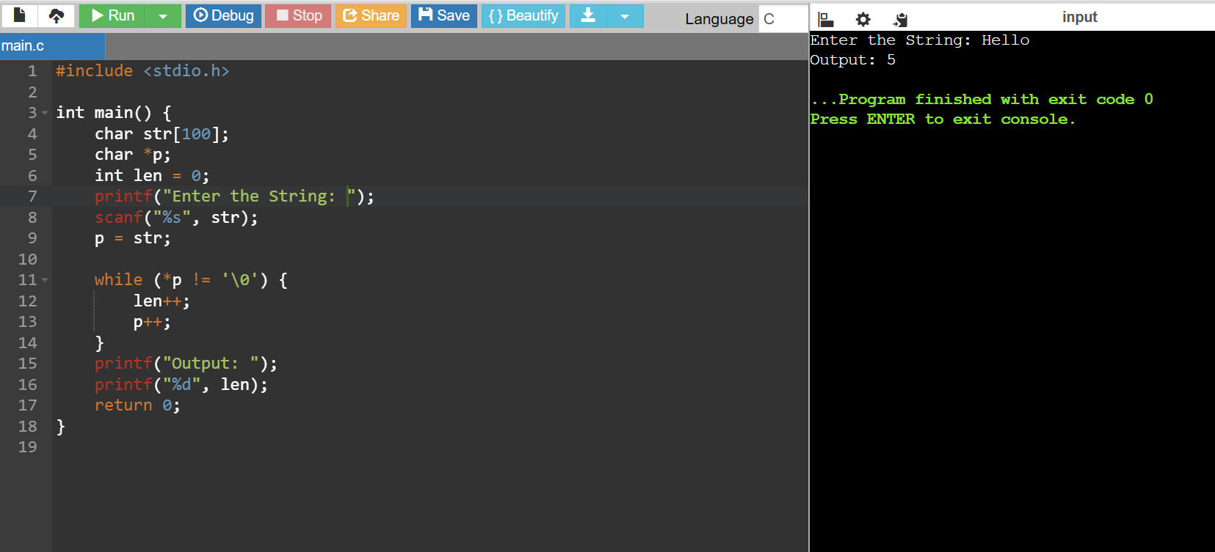

- Write a function to calculate the GCD (Greatest Common Divisor) of two numbers using recursion.

CODE:

#include <stdio.h>

int gcd(int a, int b) {
if (b == 0)
return a;
return gcd(b, a % b);
}

int main() {
int a, b;
printf("Enter a and b:");
scanf("%d %d", &a, &b);
printf("GCD is %d", gcd(a, b));

return 0;
}

OUTPUT:
